

Dokumentasi Reverse Proxy

Oleh:

Delia Risti N. 5114100033

Tionia Rizkika 5114100053

Aditya Gunawan 5114100167

Luqman Ahmad 5114100187

Daftar Isi

Pendahuluan 3

Latar Belakang 3

Rancangan Server 4

A. FITUR 4

1. Register 4

2. Login 4

3. Exit 5

4. Private Message 5

5. Check Ourself 5

6. Check Online Friend 5

7. Broadcast Message 6

8. Checkpast 6

9. Check 6

10. Logout 6

11. Create Group 6

12. Join Group 7

13. Send Message to Group 7

B. SOURCE CODE 8

C. SCREENSHOT SERVER 17

D. PEMBAGIAN TUGAS 21

Rancangan Client dari Server Kelompok lain 22

A. FITUR 22

1. Sign Up 22

2. Login 22

3. Chat Personal 23

4. Buat Group 23

5. Gabung Group 24

6. Leave Group 24

7. Chat Group 25

8. Daftar User yang Aktif 25

9. Daftar Group yang Ada 25

10. Logout 26

B. SOURCE CODE 26

C. SCREENSHOT CLIENT 36

D. PEMBAGIAN TUGAS 39

# Pendahuluan

## Latar Belakang

Adanya tugas membuat reverse proxy dalam mata kuliah Pemrograman Jaringan kelas E.

# Rancangan

Simple HTTP Server ini dirancang untuk memenuhi permintaan dokumen-dokumen seputar perkuliahan. Reverse proxy membagi kerja server untuk menangani dokumen sesuai dengan mata kuliah yang telah ditentukan.

## ARSITEKTUR SISTEM

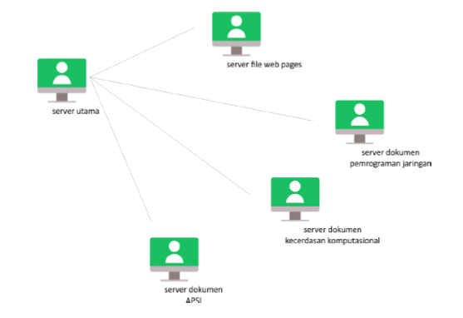

Server yang terlibat dalam arsitektur ini terdiri atas:

1. Server utama yang membagi kerja server-server di bawahnya.
2. Server tier-1
   1. Sebuah server yang menangani jenis request
   2. Tiga buah server untuk menangani permintaan dokumen

Dokumen-dokumen yang dapat ditangani oleh server-server tersebut adalah dokumen mata kuliah yang terdiri atas:

* Dokumen APSI
* Dokumen KK
* Dokumen Progjar

## SOURCE CODE

nama file : http_server.py

|  |  |
| --- | --- |
|  | import socket  import sys |
|  | import threading |
|  |  |
|  | #inisialisasi |
|  | sock = socket.socket(socket.AF_INET, socket.SOCK_STREAM) |
|  |  |
|  | #proses binding |
|  | server_address = ('localhost', 13006) |
|  | print >>sys.stderr, 'starting up on %s port %s' % server_address |
|  | sock.bind(server_address) |
|  |  |
|  | #listening |
|  | sock.listen(1) |
|  |  |
|  |  |
|  | def response_teks(): |
|  | hasil = "HTTP/1.1 200 OK\r\n" \ |
|  | "Content-Type: text/plain\r\n" \ |
|  | "Content-Length: 7\r\n" \ |
|  | "\r\n" \ |
|  | "PROGJAR" |
|  | return hasil |
|  |  |
|  | def response_gambar(): |
|  | filegambar = open('gambar.png','r').read() |
|  | panjang = len(filegambar) |
|  | hasil = "HTTP/1.1 200 OK\r\n" \ |
|  | "Content-Type: image/png\r\n" \ |
|  | "Content-Length: {}\r\n" \ |
|  | "\r\n" \ |
|  | "{}" . format(panjang, filegambar) |
|  | return hasil |
|  |  |
|  | def response_page(url): |
|  | filename = url.split("/") |
|  | filename = filename[1] |
|  | print "filename : "+filename |
|  |  |
|  | filename = "pages/"+filename |
|  |  |
|  | try: |
|  | webfile = open(filename, 'r').read() |
|  | except: |
|  | webfile = open('pages/not_found.html').read() |
|  |  |
|  | length = len(webfile) |
|  | hasil = "HTTP/1.1 200 OK\r\n" \ |
|  | "Content-Type: text/html;charset=UTF-8" \ |
|  | "Content-Length: {}\r\n" \ |
|  | "\r\n" \ |
|  | "{}" . format(length, webfile) |
|  | return hasil |
|  |  |
|  | def response_document(url): |
|  | n = len(url) |
|  | filename = url[1:n] |
|  | print "filename : "+filename |
|  |  |
|  | docfile = open(filename, 'r').read() |
|  |  |
|  | length = len(docfile) |
|  | hasil = "HTTP/1.1 200 OK\r\n" \ |
|  | "Content-Type: application/pdf" \ |
|  | "Content-Length: {}\r\n" \ |
|  | "\r\n" \ |
|  | "{}" . format(length, docfile) |
|  | return hasil |
|  |  |
|  | #fungsi melayani client |
|  | def layani_client(koneksi_client,alamat_client): |
|  | try: |
|  | print >>sys.stderr, 'ada koneksi dari ', alamat_client |
|  | request_message = '' |
|  | while True: |
|  | data = koneksi_client.recv(64) |
|  | data = bytes.decode(data) |
|  | request_message = request_message+data |
|  | if (request_message[-4:]=="\r\n\r\n"): |
|  | break |
|  |  |
|  |  |
|  | baris = request_message.split("\r\n") |
|  | baris_request = baris[0] |
|  | print "baris request[0] : "+baris_request |
|  |  |
|  | a,url,c = baris_request.split(" ") |
|  | print "url : "+url |
|  |  |
|  | ekstensi = url.split(".") |
|  | ekstensi = ekstensi[1] |
|  |  |
|  | respon = "" |
|  | if (ekstensi=='html'): |
|  | respon = response_page(url) |
|  | else: |
|  | respon = response_document(url) |
|  | koneksi_client.send(respon) |
|  | finally: |
|  | # Clean up the connection |
|  | koneksi_client.close() |
|  |  |
|  |  |
|  | while True: |
|  | # Wait for a connection |
|  | print >>sys.stderr, 'waiting for a connection' |
|  | koneksi_client, alamat_client = sock.accept() |
|  | s = threading.Thread(target=layani_client, args=(koneksi_client,alamat_client)) |
|  | s.start() |
|  |  |
|  |  |

## SCREENSHOT